3399 Agate Dr.
Santa Clara, CA 95051
(408) 422-1903
Fax: (408) 243-8299
Email: customerservice@hernaezcraftshop.com
Customer Name: |  |  | Date:
Address/Telephone No. |  | Email Address

Qty | Page # | Product # | Product Description | Price Ea. | Total Price
 |  |  |  |  | $ -
 |  |  |  |  | $ -
 |  |  |  |  | $ -
 |  |  |  |  | $ -
 |  |  |  |  | $ -
 |  |  |  |  | $ -
 |  |  |  |  | $ -
 |  |  |  |  | $ -
 |  |  |  |  | $ -
 |  |  |  |  | $ -
 |  |  |  |  | $ -
 |  |  |  |  | $ -
 |  |  |  |  | $ -
 |  |  |  |  | $ -
 |  |  |  | Subtotal: | $ -
Kindly mail this order, with your remittance, to the |  |  |  | CA Sales Tax: | $ -
Address above. Full payment is required before processing any orders. |  |  |  | S/H | $ -
 |  |  |  | Amount Due: | $ -
CANCELLATION RULE:

You may CANCEL this transaction, without any Penalty or Obligation, with a THREE BUSINESS DAYS from the date you place the order. If you failed to meet the THREE BUSINESS DAYS your payment will not be returned. You remained liable for the performance of all obligations under the contract due to seller's expense and risk. You must give 3 weeks to 1-month advance notice before placing an order. Minimum of 50 items to process any orders except the All Occasion Products. Make Check Payable To: Hernaez Craft Shop! We ship orders in any City or State.

Enclosed is the full amount of my order $__________ Paid by:

Shipping & Handling Chart
These charges represent only part of the actual costs. We'll pay the rest. If order is:
up to $14.99……….………add $6.25
from $15.00 to $19.00……add $6.55
from $20.00 to $24.99……add $6.85
from $25.00 to $29.99……add $7.75
from $30.00 to $34.99……add $8.35
from $35.00 to $39.99……add $9.35
from $40.00 to $44.99……add $10.20
from $45.00 to $49.99……add $14.95
Over $50.00………...…..…add $20.00

Check Money Order Certified Check
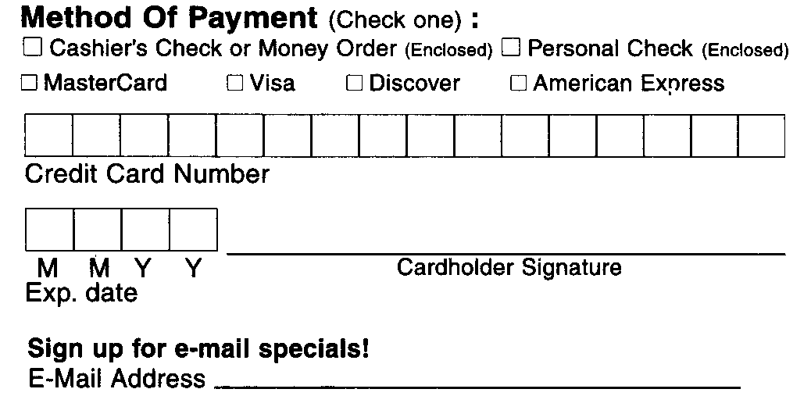
Cash Credit Card

Have A Brochure Sent To A Friend or Company. Free!

Name: ___________________________________
Address: _________________________________
City/State/ZIP: ____________________________

